

**PROJECT REPORT**

**JOB PORTAL**

**SOFTWARE ENGINEERING: SECTION 4-B**

**GROUP MEMBERS**

**Daniyal Wajid (48528)**

**Uzair Hassan (48525)**

**Submitted to: Mr. Muhammad Adnan**

**Date: 25th June-2024**

Table of Contents:

1. Project Description
   1. Scope
   2. Major Features
2. Stakeholders List

1. Elicitation Plan & Results
   1. Description of Elicitation Plan
   2. Interviews
   3. Surveys
   4. Prototypes
2. Functional, Non-Functional, Constraint & Domain Requirements
   1. Functional Requirements
   2. Non-Functional Requirements
   3. Constraint Requirements
   4. Domain Requirements
3. Implementation of Requirements Analysis Technique
   1. Checklist
4. Graphical Models of Requirements
   1. Use Case Diagram
   2. Class Diagram
   3. Activity Diagram
   4. Sequence Diagram
   5. State Diagram
5. Use Case Description
   1. Use Case 1
   2. Use Case 2
   3. Use Case 3
   4. Use Case 4
   5. Use Case 5
   6. Use Case 6
   7. Use Case 7
   8. Use Case 8
6. Prototypes & Graphical User Interfaces
7. Feature Prioritization Technique
   1. MoSCoW
8. Requirements Traceability Matrix
   1. RTM
   2. Validation Technique
9. Lesson Learned

1. **Project Description:** 
   1. **Scope:**

Job seekers and companies can easily and effectively interact with RIZQ, a cutting-edge online job platform. The Rizq Job Portal project's objective includes creating a thorough web platform with the goal of effectively matching job seekers and businesses. It has features including the ability to register users and create profiles, a powerful job search engine, an employer portal for managing applications and job postings, a safe backend database, and communication tools for easy user engagement. In order to guarantee usability for businesses and job seekers alike, the scope also includes the development of comprehensive documentation and support systems. Direct recruitment services, offline initiatives, and integrations that go beyond the specified parameters are not included in the scope. The initiative aims to prioritize data security, privacy, and regulatory compliance while offering a user-friendly platform for recruiting and job search.

* 1. **Major Features:**

**Key Features:**

* + - * User registration: A simple online form that job seekers fill out to create an account.
      * Job Search: Extensive search features make it possible for job searchers to locate relevant positions.
      * Employer Portal: Employers can publish job openings and monitor the recruitment process on a dedicated employer portal.
      * Database: Job Seeker Profiles and Resumes are stored in a secure backend database.
      * Tools for Communication: Make it easier for companies and job seekers to communicate.
      * Installation, configuration, and support instructions: This makes it simple for companies and job seekers to set up and use.
      * User and Technical Support: Committed to addressing both technical and user-related problems.

**Additional Features:**

* + - * Application Tracking: Job searchers can monitor the progress of their applications with Application Tracking.
      * Resume management is simple for job seekers to upload and maintain.
      * Management of Job Postings: Employers are able to effectively handle job postings and applications.
      * Career Resources: Provide resources, advice, and articles to help job seekers advance their careers.
      * Premium Features: Provide employers with premium features to improve their hiring procedures.

**Benefits:**

* + - * Easy Job Search: Using their choices as a guide, job searches can quickly locate relevant positions.
      * Effective Hiring: Companies can locate competent applicants quickly by streamlining their hiring procedures.
      * Enhanced User Experience: The user experience is enhanced overall by features like resume management and application tracking.
      * Valuable Insights: Provide companies with useful information so they may examine candidate feedback and hiring trends in order to make ongoing improvements.

1. **Stakeholders List:**

|  |  |  |
| --- | --- | --- |
| **Stakeholder** | **Category** | **Role/Duty** |
| Job Seekers | Primary | People who use Rizq to look for jobs, make profiles, and apply for jobs are those who are actively looking for work. |
| Employers | Primary | Employers and groups seeking to expand their workforce use Rizq to advertise positions, handle applications, and find applicants. |
| Recruitment Agencies | Secondary | Recruitment and hiring agencies that could use Rizq to find candidates for their clients. |
| Educational Institutes | Secondary | Universities, colleges, and technical schools that use Rizq to help their alumni and students find employment. |
| Investors | Supportive | People or groups with financial stakes in Rizq who are motivated to see it succeed and turn a profit. |
| Advertisers | Supportive | Businesses that use Rizq to market their goods or services in order to connect with employers and job seekers. |
| Employees | Internal | The internal group that develops, maintains, and runs  Rizq; this group consists of programmers, customer service agents, marketers, and administrators. |

1. **Elicitation Plan & Results:**

* 1. **Description of Elicitation Plan:**

Elicitation is the process of using different methods, such as surveys, interviews, and prototypes, to gain a thorough understanding of user needs and preferences. It involves collecting input from customers and end users and evaluating it to guide the creation and improvement of products and services. In the end, elicitation seeks to guarantee that user expectations and company goals are correlated.

The Elicitation Techniques we are using are:

* + - * + Interviews
        + Surveys
        + Prototyping

* 1. **Interviews:**

Direct conversations that are meant to comprehend viewpoints, beliefs, or experiences; frequently utilized in problem-solving or research. They are quite famous for gathering information from the Stakeholders.

* + 1. **Do you want a job posting system?**

Yes, for employers to post job vacancies.

* + 1. **How long should a job listing remain active on the platform?** Typically, 30 days.

* + 1. **How many job postings should be displayed per page?** Around 10 to 20 listings per page.

* + 1. **What is your budget for developing and maintaining the platform?**

Approximately 5 to 10 lac rupees.

* + 1. **What kind of security measures do you want for user data?** Secure encryption and access controls.

* + 1. **Who should have access to candidate information?**

Employers and authorized platform administrators.

* + 1. **Who has authority to edit and update job listings?**

Employers and platform administrators.

* + 1. **Can job seekers save job listings for later viewing?**

Yes, with a bookmark or save feature.

* + 1. **How long can a job seeker bookmark a job listing?**

Indefinitely until removed by the user.

* + 1. **What if a job posting is filled or no longer available?**

It will be marked as closed or removed from listings.

* + 1. **What categories of jobs are you looking to feature on the platform?**

Various industries and job types based on user demand.

* + 1. **What are the preferred methods for job seekers to search for jobs?**

Search by industry, location, salary, etc.

* 1. **Surveys:**

* + 1. What is your age?
    2. What is your gender identity?
    3. What is your educational background?
    4. What is your employment status?
    5. What is your geographic location?
    6. How frequently do you use job portals to search for employment opportunities?
    7. Which job portals do you currently use, if any?
    8. How satisfied are you with the usability and design of the job portals you use?
    9. What features do you find most useful in a job portal?
    10. How likely are you to recommend the job portals you use to others? What challenges do you encounter when using job portals for job search?
    11. What additional features or improvements would you like to see in job portals?
    12. How important are factors such as job relevance, location, salary, and company reputation when considering job listings?
    13. What types of job listings are you most interested in (e.g., full-time, part-time, remote, freelance)?
    14. Do you encounter any accessibility barriers when using job portals? If so, please specify.
    15. How important is it for job portals to be inclusive of diverse backgrounds, identities, and abilities?
    16. Are there any specific accommodations or features that would make job portals more accessible and inclusive for you?
    17. Do you have any additional comments, suggestions, or feedback regarding job portals that you would like to share?
    18. Is there anything else you would like to see addressed in future updates or developments of job portals?
  1. **Prototypes**

**Why we use Prototype Technique?**

Prototyping in Software Engineering is a technique where an initial, simplified version of the system (a prototype) is built to understand requirements, demonstrate concepts, and validate design choices. This iterative process allows for user feedback and refinements before final development.

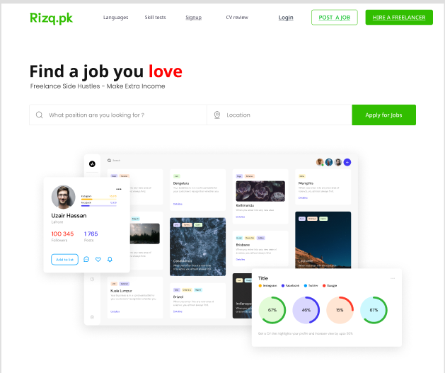

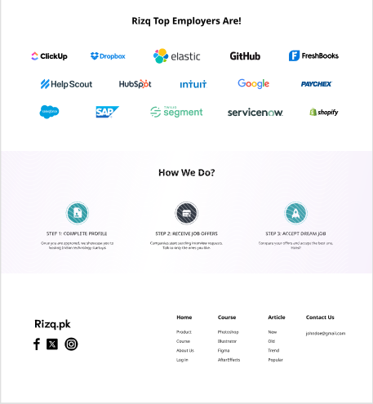

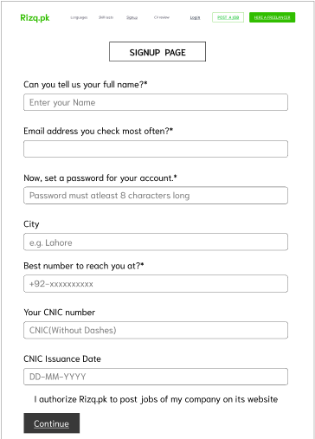

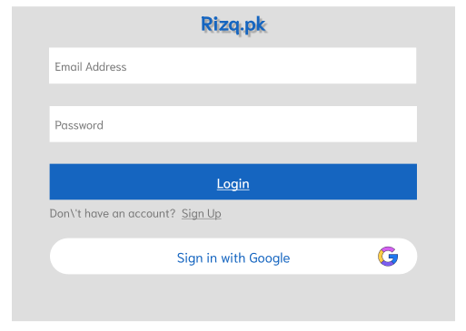

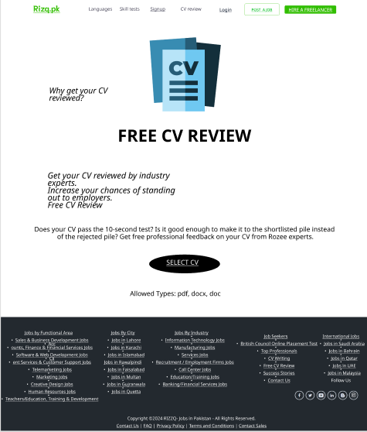

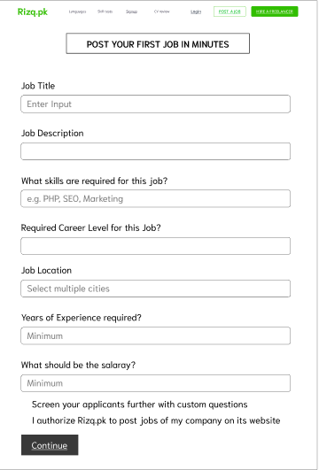

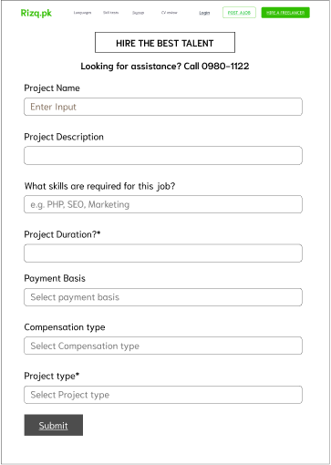

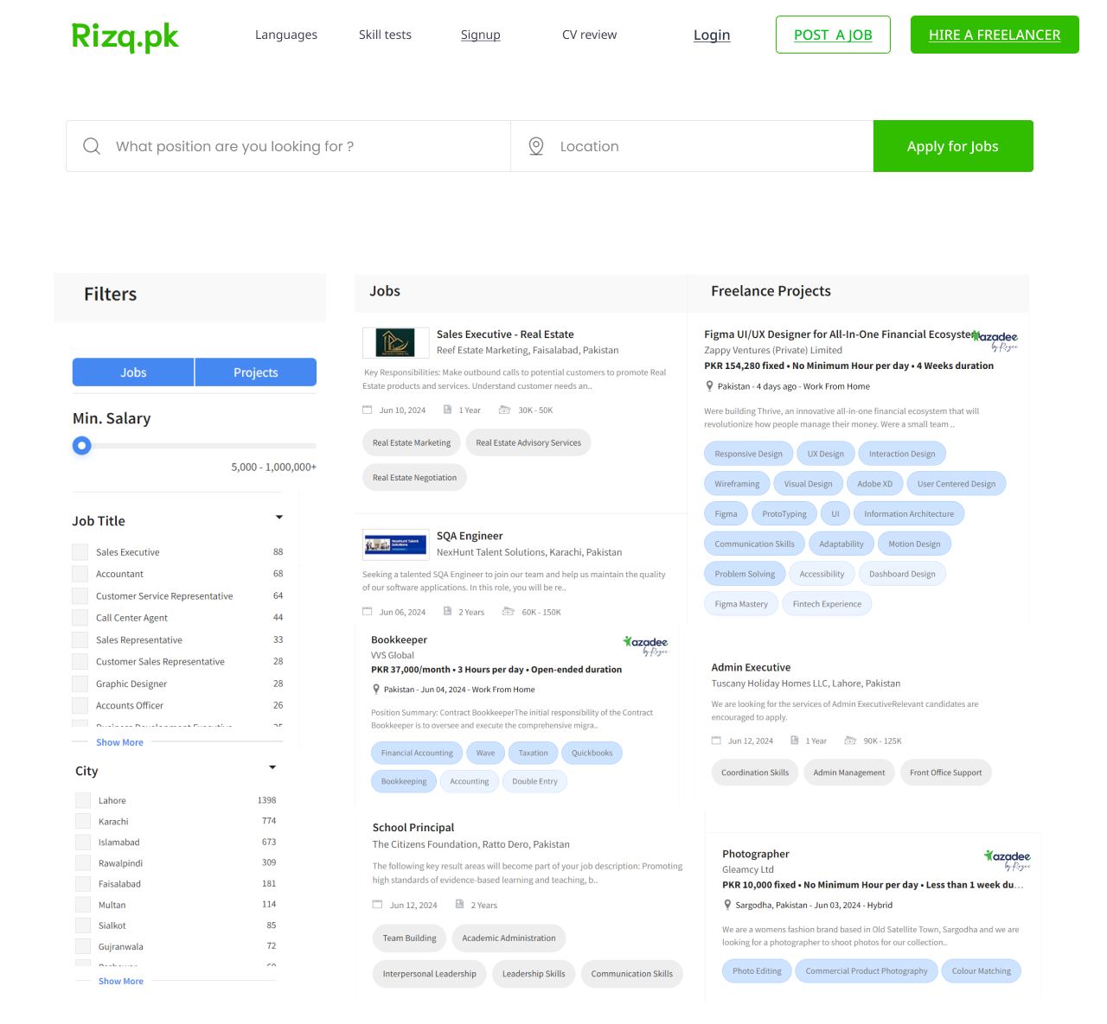

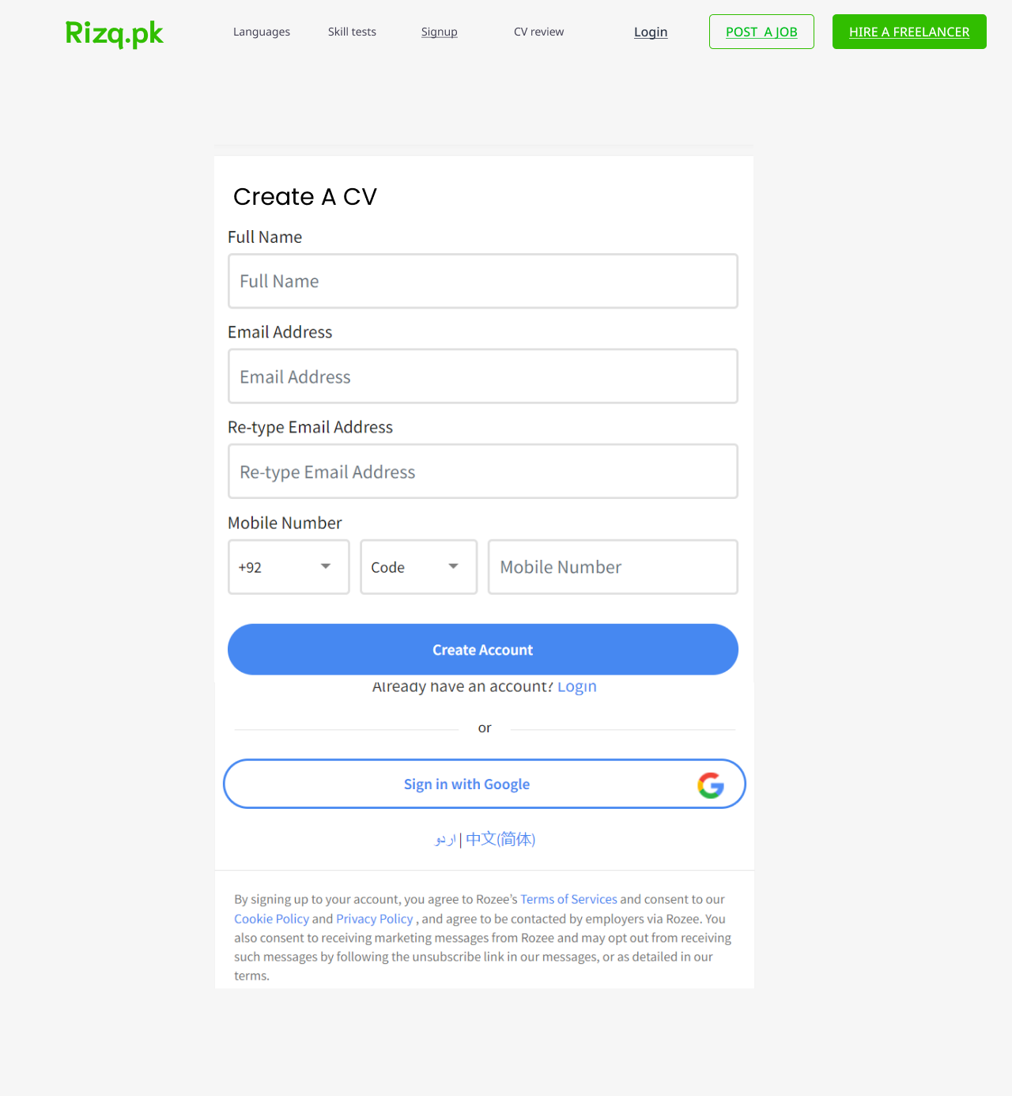

1. **Set of Functional, Non-Functional, Constraint & Domain Requirements**

**4.****1. Functional Requirements Description**

|  |  |  |
| --- | --- | --- |
| **Functional Req. ID #** | **Function Name** | **Function Requirement Description** |
| FR1 | Login | Registration and authentication |
| FR2 | Profile management | Registered users should have the ability to edit and update their profiles |
| FR3 | Job Posting | Employers should be able to post jobs |
| FR4 | Job Search | Users should be able to search for jobs based on different criteria’s |
| FR5 | Analytics | The platform provides analytics and reporting features for employers and administrators |
| FR6 | Notifications | Users should receive notifications for new job postings, application status updates, messages, etc. |
| FR7 | Communication | The platform should facilitate communication between job seekers and employers |
| FR8 | Emp dashboard | Employers should have access to a dashboard |
| FR9 | Job Alerts | Users should be able to set up job alerts based on their search criteria |
| FR10 | Helpdesk | Section or helpdesk where users can find answers to frequently asked questions (FAQs) |
| FR11 | API integration | Allowing third-party developers to build custom applications or integrate with existing HR systems. |
| FR12 | Feedback | Users should be able to provide feedback and reviews |

**4.2. Non-Functional Requirements Description**

|  |  |  |
| --- | --- | --- |
| **Non-Functional Req. ID #** | **Function Name** | **Function Requirement Description** |
| NFR1 | Performance | Fast response times and ability to handle high concurrency. |
| NFR2 | Scalability | Seamless accommodation of increasing user and job posting volumes. |
| NFR3 | Security | Ensuring secure storage and transmission of sensitive data. |
| NFR4 | Reliability | High availability and minimal downtime for uninterrupted service. |
| NFR5 | Usability | Intuitive and user-friendly interface for diverse users. |
| NFR6 | Accessibility | Compliance with accessibility standards for users with disabilities. |
| NFR7 | Compatibility | Consistent experience across various devices and browsers. |
| NFR8 | Regulatory Compliance | Adherence to local labor laws and regulations in job postings and hiring processes. |
| NFR9 | Maintainability | Clear and modular code for ease of maintenance and updates. |
| NFR10 | Robustness | Robust backup and recovery procedures for business continuity. |

* 1. **Constraint Requirements Description**

|  |  |  |
| --- | --- | --- |
| **Constraint Req. ID #** | **Function Name** | **Constraint Requirement Description** |
| CON 1 | Budget: | Development and maintenance must stay within the allocated budget. |
| CON 2 | Timeline | The portal must be fully functional and ready for launch within the specified timeline. |
| CON 3 | Regulatory Compliance | Ensure compliance with local labor laws, data privacy, and security regulations. |

* 1. **Domain Requirements Description**

|  |  |  |
| --- | --- | --- |
| **Domain Req. ID #** | **Function Name** | **Constraint Requirement Description** |
| DOM 1 | User Permission | Support different user roles (job seekers, employers, administrators) with specific permissions. |
| DOM 2 | Job Posting | Enable employers to create, update, and manage job postings |
| DOM 3 | Search Functionality | Provide advanced search capabilities based on criteria like location and job type |
| DOM 4 | Analytics | Provide analytics and reporting features for employers |

# 5. Implementation of Analysis Techniques

**5.****1Checklist:**

|  |  |  |  |  |  |
| --- | --- | --- | --- | --- | --- |
| **Requirement Id** | **Complete** | **Non-Ambiguous** | **Testable** | **Necessary** | **Confliction** |
| FR 1 | ✔ | ✔ | ✔ | ✔ | ✖ |
| FR 2 | ✔ | ✔ | ✔ | ✔ | ✖ |
| FR 3 | ✔ | ✔ | ✔ | ✔ | ✖ |
| FR 4 | ✔ | ✔ | ✔ | ✔ | ✖ |
| FR 5 | ✔ | ✔ | ✔ | ✔ | ✖ |
| FR 6 | ✔ | ✔ | ✔ | ✔ | ✖ |
| FR 7 | ✔ | ✔ | ✔ | ✔ | ✖ |
| FR 8 | ✔ | ✔ | ✔ | ✔ | ✖ |
| FR 9 | ✔ | ✔ | ✔ | ✔ | ✖ |
| FR 10 | ✔ | ✔ | ✔ | ✔ | ✖ |
| FR 11 | ✔ | ✔ | ✔ | ✔ | ✖ |
| FR 12 | ✔ | ✔ | ✔ | ✔ | ✖ |

To ensure the quality of the requirements for the Job Portal project, we utilized a checklist to evaluate each of the twelve requirements (FR 1 to FR 12). Each requirement was assessed to ensure it is complete, clear, testable, necessary, and free of conflicts. This approach allows us to identify and resolve issues early on, ensuring the requirements are robust and ready for implementation.

1. **Graphical Models of requirement**

**6.1 Use-case Diagram**

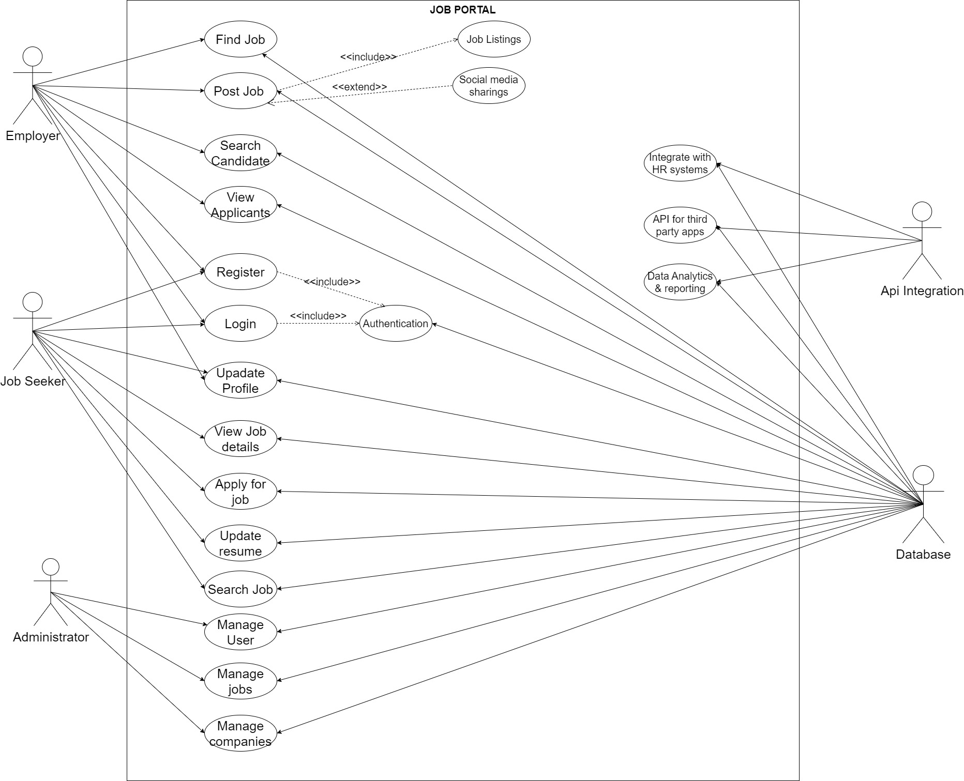

**6.2** **Class Diagram**

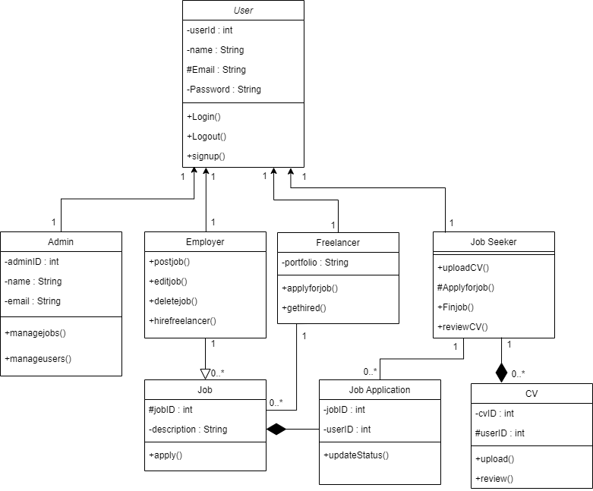

**6.3** **Activity Diagram**

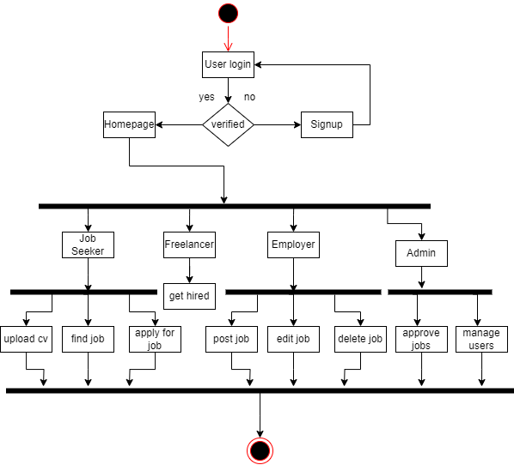

**6.4** **Sequence Diagram**

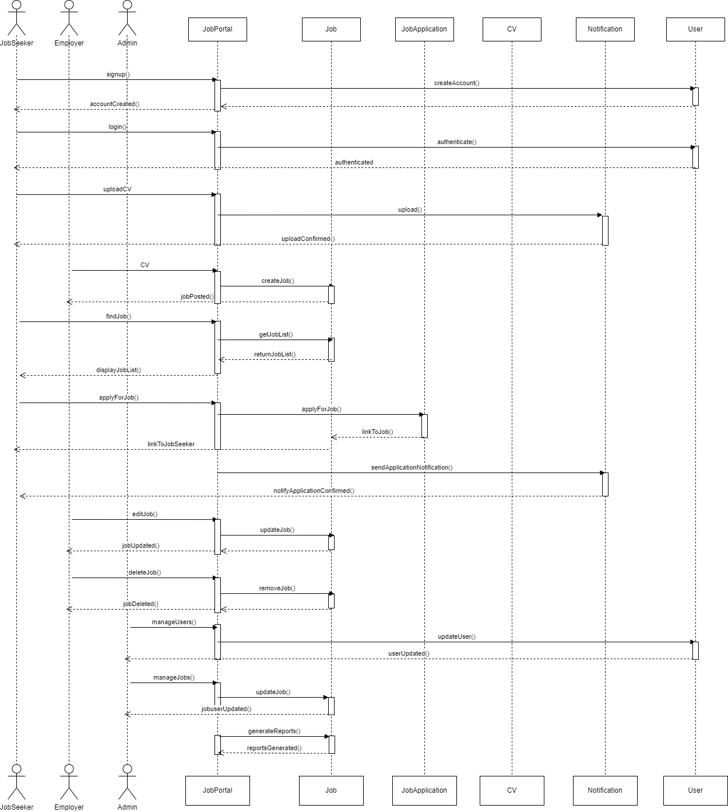

* 1. **State Diagram**

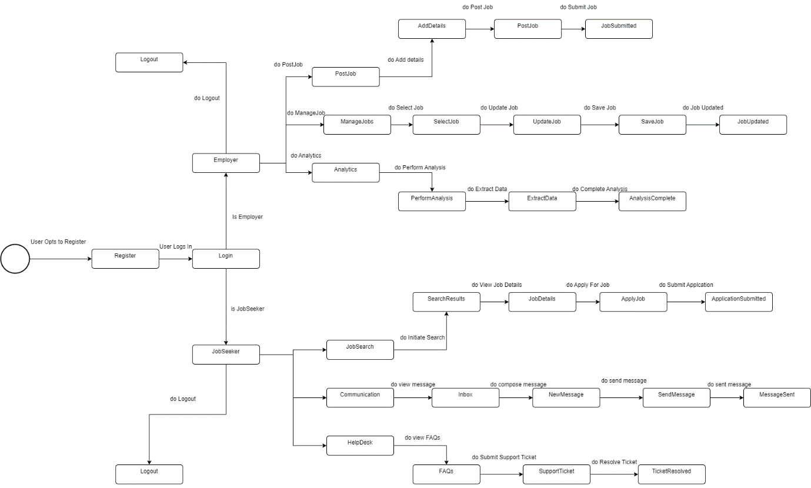

**7. Use-Case Descriptions**

1. 1 Use Case 1:

|  |  |
| --- | --- |
| **Use Case** | **User Registration** |
| Description | Users, including job seekers and employers, can register for an account on the job portal by providing their credentials. |
| Primary Actor | Job Seeker/Employer |
| Goal | The users can register to the system. |
| Pre-Condition | None |
| Post-Condition | The user is registered and can log in to the system. |
| Trigger | After successful registration, the user can log in and book appointments. |
| Scenario | The user navigates to the registration page.  The user provides necessary information (name, email, password, etc.).  The system validates the provided information.  The user receives a confirmation email. |

7.2 Use Case 2:

|  |  |
| --- | --- |
| **Use Case** | **Profile Management** |
| Description | Users can manage their profiles by updating personal and professional information. |
| Primary Actor | Job Seeker/Employer |
| Goal | The users can update their profiles. |
| Pre-Condition | The user is logged in. |
| Post-Condition | The user's profile is updated. |
| Trigger | The user wants to update their profile information. |
| Scenario | The user updates professional information (resume, job preferences, etc.).  The user saves the changes.  The system updates the user's profile. |

7.3 Use Case 3:

|  |  |
| --- | --- |
| **Use Case** | **Job Posting** |
| Description | Employers can post job openings on the job portal. |
| Primary Actor | Employer |
| Goal | The users can update their profiles. |
| Pre-Condition | The user is logged in. |
| Post-Condition | The job posting is available for job seekers to view. |
| Trigger | The employer wants to post a new job opening. |
| Scenario | The system validates the provided information.  The employer confirms the job posting.  The job posting is created and available for job seekers. |

7.4 Use Case 4:

|  |  |
| --- | --- |
| **Use Case** | **Job Search** |
| Description | Job seekers can search for job openings. |
| Primary Actor | Job Seeker |
| Goal | Job seekers can find job openings relevant to their skills and preferences. |
| Pre-Condition | The job seeker is logged in. |
| Post-Condition | The job seeker can view and apply for job openings. |
| Trigger | The job seeker wants to find job openings. |
| Scenario | The system displays matching job openings.  The job seeker views details of selected job openings.  The job seeker applies for desired job openings. |

7.5 Use Case 5:

|  |  |
| --- | --- |
| **Use Case** | **Analytics** |
| Description | Employers can view analytics related to job postings and applications. |
| Primary Actor | Employer |
| Goal | Employers can analyze the performance of their job postings. |
| Pre-Condition | The employer is logged in. |
| Post-Condition | The employer can view analytics data. |
| Trigger | The employer wants to view job posting performance data. |
| Scenario | The employer navigates to the analytics page.  The system retrieves analytics data (views, applications, etc.).  The employer views and analyzes the data. |

7.6 Use Case 6:

|  |  |
| --- | --- |
| **Use Case** | **Communication** |
| Description | Users can communicate with each other through the job portal. |
| Primary Actor | Job Seeker/employer |
| Goal | Users can send and receive messages. |
| Pre-Condition | The user is logged in. |
| Post-Condition | The messages are sent and received. |
| Trigger | The user wants to communicate with another user. |
| Scenario | The user navigates to the communication page.  The user selects the recipient.  The user writes and sends a message. |

7.7 Use Case 7:

|  |  |
| --- | --- |
| **Use Case** | **Job Alerts** |
| Description | Job seekers can set up job alerts based on their preferences. |
| Primary Actor | Job Seeker |
| Goal | Job seekers receive notifications about new job postings matching their criteria. |
| Pre-Condition | The job seeker is logged in. |
| Post-Condition | The job seeker receives job alerts. |
| Trigger | New job postings match the job seeker's criteria. |
| Scenario | The job seeker navigates to the job alerts page.  The job seeker sets up alert criteria (keywords, location, etc.).  The system saves the alert criteria. |

7.8 Use Case 8:

|  |  |
| --- | --- |
| **Use Case** | **Helpdesk** |
| Description | Users can access support and help resources. |
| Primary Actor | Job Seeker/employer |
| Goal | Users can resolve issues and find answers to their questions. |
| Pre-Condition | The user is registered. |
| Post-Condition | The user's issue is resolved or they find the needed information. |
| Trigger | The user needs assistance. |
| Scenario | The user navigates to the helpdesk page.  The user searches for help topics or submits a support ticket. |

8. Prototypes & Graphical User Interfaces:

 User Sign-up:

User Login:



Home Page:



Post a Job:



Create a CV:



1. **Feature Prioritization Technique**

### **9.1 MoSCoW**

**Functional Requirements:**

1. **FR1: Login**
   * Registration and authentication are critical for user access and security.
2. **FR2: Profile Management**
   * Users need to manage and update their profiles, essential for personalized experience and accuracy.
3. **FR3: Job Posting**
   * Employers must be able to post jobs, which is the core functionality of the platform.
4. **FR4: Job Search**
   * Users should be able to search for jobs based on various criteria, crucial for job seekers.
5. **FR5: Analytics**
   * Providing analytics and reporting features to employers and administrators to track platform usage and effectiveness.
6. **FR6: Notifications**
   * Users need to receive notifications for new job postings, application status updates, messages, etc., for timely updates.
7. **FR7: Communication**
   * Facilitating communication between job seekers and employers is essential for the hiring process.
8. **FR8: Employer Dashboard**
   * Employers require access to a dashboard to manage posted jobs, applications, and other activities.
9. **FR9: Job Alerts**
   * Users should have the ability to set up job alerts based on their preferences to stay informed about relevant job postings.
10. **FR10: Helpdesk**
    * Providing a section or helpdesk with FAQs helps users find answers and resolve common issues efficiently.
11. **FR11: API Integration**
    * Allowing third-party developers to integrate with existing HR systems or build custom applications extends platform functionality.
12. **FR12: Feedback**
    * Users should be able to provide feedback and reviews, fostering continuous improvement.

**Non-Functional Requirements:**

1. **NFR1: Performance**
   * Fast response times and optimized performance under high concurrency to ensure user satisfaction and efficiency.
2. **NFR2: Scalability**
   * Ability to scale seamlessly to accommodate increasing user and job posting volumes without compromising performance.
3. **NFR3: Security**
   * Ensuring secure storage and transmission of sensitive user data and job information to protect privacy and prevent unauthorized access.
4. **NFR4: Reliability**
   * High availability and minimal downtime to ensure uninterrupted service and reliability for users and employers.
5. **NFR5: Usability**
   * Intuitive and user-friendly interface design for easy navigation and usage by diverse users.

#### Should Have

**Functional Requirements:**

* FR3: User can view Bus/Train Schedules & Routes.
* FR7: User can rate drivers according to their ride experiences.
* FR8: User should receive discounts according to ongoing offers.

**Non-Functional Requirements:**

* NFR2: User should have a robust backend infrastructure.
* NFR8: DriveDex should offer 24/7 customer support through multiple channels.
* NFR9: DriveDex should monitor app performance to identify bottlenecks.

#### Could Have

**Functional Requirements:**

* FR6: Personalized ride recommendations based on user behavior.
* FR9: Social features for users to share ride experiences.

#### Won't Have (for this release)

**Functional Requirements:**

* FR10: In-app chat for drivers and users.
* FR11: Bonuses for drivers to take longer routes.
* FR12: Integration with public transportation systems beyond bus/train schedules (like metro, orangetrain).
* FR13: Leaderboards for drivers to improve their ratings.
* FR14: Priority booking for frequent users.
* FR15: In-app payment and tipping options.
* FR16: Driver training and certification programs.

1. Requirements Traceability Matrix 
   1. RTM

| **Requirement ID** | **FR1** | **FR2** | **FR3** | **FR4** | **FR5** | **FR6** | **FR7** | **FR8** | **FR9** | **FR10** | **FR11** | **FR12** |
| --- | --- | --- | --- | --- | --- | --- | --- | --- | --- | --- | --- | --- |
| FR1 | * |  |  |  |  |  |  |  |  |  |  |  |
| FR2 | * | * |  |  |  |  |  |  |  |  |  |  |
| FR3 |  |  | * |  |  |  |  | * |  |  |  |  |
| FR4 |  |  |  | * |  |  |  |  | * |  |  |  |
| FR5 |  |  |  |  | * |  |  | * |  |  |  |  |
| FR6 |  |  |  |  |  | * |  |  | * |  |  |  |
| FR7 |  |  |  |  |  |  | * |  |  |  |  |  |
| FR8 |  |  | * |  |  |  |  | * |  |  |  |  |
| FR9 |  |  |  | * |  | * |  |  |  |  |  |  |
| FR10 |  |  |  |  |  |  |  |  |  | * |  |  |
| FR11 |  |  |  |  |  |  |  |  |  |  | * |  |
| FR12 |  |  |  |  |  |  |  |  |  | * |  | * |

**Verification**

* **FR1: Login** maps to **User registration**
* **FR2: Profile Management** maps to **User registration** and **Database**
* **FR3: Job Posting** maps to **Employer Portal** and **Management of Job Postings**
* **FR4: Job Search** maps to **Job Search** and **Job Alerts**
* **FR5: Analytics** maps to **Premium Features** and **Employer Portal**
* **FR6: Notifications** maps to **Tools for Communication** and **Job Alerts**
* **FR7: Communication** maps to **Tools for Communication**
* **FR8: Employer Dashboard** maps to **Employer Portal** and **Management of Job Postings**
* **FR9: Job Alerts** maps to **Job Search** and **Tools for Communication**
* **FR10: Helpdesk** maps to **User and Technical Support**
* **FR11: API Integration** maps to **Installation, configuration, and support**
* **FR12: Feedback** maps to **User and Technical Support**

This matrix ensures all functional requirements are properly traced to the key features, providing a comprehensive overview of the system's capabilities.

10.2 Validation Technique:

• **User Acceptance Testing (UAT)**:

* **Importance**: UAT ensures that your social media platform meets the needs and expectations of actual end-users before deployment.
* **Application**: Engage beta testers or representative users to test all functionalities, interactions, and overall usability of the platform.

• **Performance Testing**:

* **Importance**: Ensures your platform can handle the expected load of users and interactions without performance degradation.
* **Application**: Test scenarios such as posting, commenting, media uploads to measure response times, resource usage, and scalability.

• **Security Testing**:

* **Importance**: Critical for protecting user data and maintaining trust.
* **Application**: Conduct penetration testing, vulnerability assessments, and code reviews to identify and fix security vulnerabilities.

• **Usability Testing**:

* **Importance**: Ensures the platform is user-friendly and intuitive, crucial for user retention.
* **Application**: Test navigation, layout, accessibility, and overall ease of use with real users to gather feedback for improvement.

• **Integration Testing**:

* **Importance**: Validates interactions and data flow between different components/modules.
* **Application**: Test APIs, third-party integrations, and ensure seamless functionality across various parts of the platform.

• **Regression Testing**:

* **Importance**: Ensures that recent changes or updates do not negatively impact existing functionalities.
* **Application**: Re-run tests on previously working features to detect any unintended side effects from new developments.

| **Requirement ID** | **Function Name** | **Requirement Description** | **Key Features / Additional Features** | **Test Case ID** |
| --- | --- | --- | --- | --- |
| FR1 | Login | Registration and authentication | User registration | TC_FR1 |
| FR2 | Profile management | Registered users should have the ability to edit and update their profiles | User registration, Database | TC_FR2 |
| FR3 | Job Posting | Employers should be able to post jobs | Employer Portal, Management of Job Postings | TC_FR3 |
| FR4 | Job Search | Users should be able to search for jobs based on different criteria | Job Search | TC_FR4 |
| FR5 | Analytics | The platform provides analytics and reporting features for employers and administrators | Premium Features | TC_FR5 |
| FR6 | Notifications | Users should receive notifications for new job postings, application status updates, messages, etc. | Tools for Communication | TC_FR6 |
| FR7 | Communication | The platform should facilitate communication between job seekers and employers | Tools for Communication | TC_FR7 |
| FR8 | Emp dashboard | Employers should have access to a dashboard | Employer Portal | TC_FR8 |
| FR9 | Job Alerts | Users should be able to set up job alerts based on their search criteria | Job Search | TC_FR9 |
| FR10 | Helpdesk | Section or helpdesk where users can find answers to frequently asked questions (FAQs) | User and Technical Support | TC_FR10 |
| FR11 | API integration | Allowing third-party developers to build custom applications or integrate with existing HR systems. | Installation, configuration, and support | TC_FR11 |
| FR12 | Feedback | Users should be able to provide feedback and reviews | User and Technical Support | TC_FR12 |
| NFR1 | Performance | Fast response times and ability to handle high concurrency. | - | TC_NFR1 |
| NFR2 | Scalability | Seamless accommodation of increasing user and job posting volumes. | - | TC_NFR2 |
| NFR3 | Security | Ensuring secure storage and transmission of sensitive data. | Database | TC_NFR3 |
| NFR4 | Reliability | High availability and minimal downtime for uninterrupted service. | - | TC_NFR4 |
| NFR5 | Usability | Intuitive and user-friendly interface for diverse users. | User registration, Job Search, Employer Portal | TC_NFR5 |
| NFR6 | Accessibility | Compliance with accessibility standards for users with disabilities. | - | TC_NFR6 |
| NFR7 | Compatibility | Consistent experience across various devices and browsers. | - | TC_NFR7 |
| NFR8 | Regulatory Compliance | Adherence to local labor laws and regulations in job postings and hiring processes. | - | TC_NFR8 |
| NFR9 | Maintainability | Clear and modular code for ease of maintenance and updates. | - | TC_NFR9 |
| NFR10 | Robustness | Robust backup and recovery procedures for business continuity. | - | TC_NFR10 |

1. Lesson Learned

We learned understanding of the significance of precise documentation, comprehensive requirements collecting, iterative development, and open communication. The important things were to follow non-functional criteria, use graphical models efficiently, and strike a balance between usefulness and usability. For the project to be successful, it was imperative to manage time and budget, ensure traceability, and promote team communication.